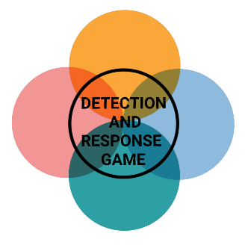

**IMPACT**



**IMPACT**



**IMPACT**



**IMPACT**

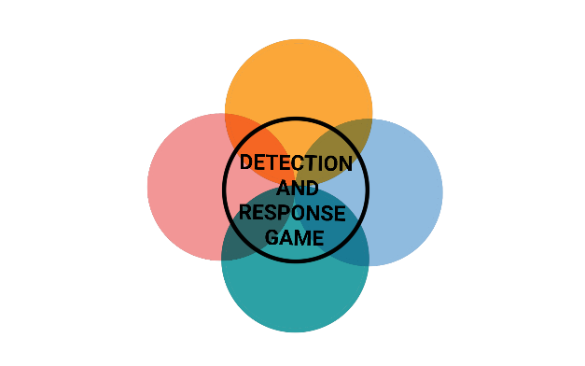

**INITIAL ACCESS**



**INITIAL ACCESS**



**INITIAL ACCESS**



**INITIAL ACCESS**



**IMPACT**



**IMPACT**



**IMPACT**



**IMPACT**

**ACCOUNT ACCESS REMOVAL**

The hacker changed the passwords of all administrator accounts and logged off active users.

PREVENTION

Two- factor authentication for user privilege changes

DETECTION

Monitor for large quantities of user privilege changes

**RESOURCE HIJACKING**

The hacker uses network resources to mine cryptocurrency with a crypto jacking script.

PREVENTION

Disable JavaScript

DETECTION

Monitor for common crypto mining software

**SERVICE STOP**

The hacker stopped or disabled the email service to make it unavailable to all employees.

PREVENTION

Limit privileges of user accounts and groups

DETECTION

Monitor for edits or modifications to services and startup programs

**DATA DESTRUCTION**

The hacker has overwritten large amounts of files and folders on every Windows device outside of the Windows folder with randomly generated data.

PREVENTION

Diversify backups

DETECTION

Monitor for large quantities of file modifications



**INITIAL ACCESS**



**INITIAL ACCESS**



**INITIAL ACCESS**



**INITIAL ACCESS**

**DEFACEMENT**

The hacker modifies the content of the company's official website in order to create a bad reputation.

PREVENTION

Diversify backups

DETECTION

Monitor websites for unplanned content changes

**DATA ENCRYPTED FOR IMPACT**

The hacker encrypts large amounts of data to interrupt availability of system and network resources.

PREVENTION

Diversify backups

DETECTION

Monitor for large quantities of file modifications

**NETWORK DENIAL OF SERVICE**

The hacker performs a Network Denial of Service attack on the DNS.

PREVENTION

Filter network traffic

DETECTION

Network monitoring tools

**DATA MANIPULATION**

The hacker changes important product data to affect production.

PREVENTION

Encrypt sensitive information

DETECTION

Inspect important file hashes